Final Project Proposal

**Team Members**

Ziyan Bi & Yuxin He

**Programming platform**

Web Audio

**Product goal/purpose**

In our project, we intend to create a web page that not only provides users with a range of comforting sounds, but also records their work or study time to help them better focus on the task at hand that requires concentration.

The web page will provide a variety of ambient sounds, such as raindrops falling on a window, leaves being ruffled by the breeze, soft piano music, etc., aiming to create a relaxing, concentration-inducing atmosphere. At the same time, users can use the page to record their work or study time and set reminders to ensure they make the most of their time and stay focused. In this way, we hope to provide users with a tool that will help improve their work and study efficiency, and enable them to manage their time and energy more easily.

**Anticipated result (what exactly the product will do)**

**We plan to develop an online web page in which the following features will be provided:**

1. **Multiple audio sources** and their corresponding players located on the same page, with **the background of the page changing as the music switches**. The player itself will have **start and stop** functionality, with start as well as pause buttons provided at appropriate locations.

2. The main page will be used to introduce the content of the page and provide the user with **a choice of states (study/work/sleep)**, while the sub-pages will provide **categorization functions (Music List)**, including songs, white noise, cosmic echoes, nature sounds, etc.

3. The web page will also display **the time** and plans to further **associate the time with the user's state**. The user can select the current state, such as study, work, sleep, etc., and the corresponding text will be displayed according to the selected state. For example, if you select the learning state, when you pause the web page, it will display a message like "Congratulations you have studied for XX time!" message.

4. **(Extra:Might not do)** We also considered providing users with a more convenient interface, so that they can easily **adjust the background image or even the music.**

**User Interface**

**We have specific images shown how the web accept the user input below**

**Timeline of required steps and intermediate goals**

**(not the final version, may change due to difficulty and timing of tasks)**

**Week 6 - 7**

**Ziyan:** Create the web page, implement the audio play and toggle functions, add start and pause buttons.

**Yuxin:** Design and build the main interface/homepage, collect the required audio and UI materials.

**Week 8**

Ziyan: Add the categorization feature to allow users to browse different types of music according to their needs.

Yuxin: Design the UI, add the music text/ and music, and prepare the text for the "Status" and "Clock" functions.

**Week 9**

**Ziyan:** Implement a clock function while completing previously unfinished tasks. If there is free time, start experimenting with additional features.

**Yuxin:** Continue to adjust the UI design and optimize the overall visual effect. If there is free time, will try to add dynamic background images and animation effects that support page interaction to the page.

**Week 10 - Final**

Finish all previously unfinished tasks and further improve the overall effect to ensure that the web page meets expectations.

**Here’s the graph of showing the specific tasks in timeline:**

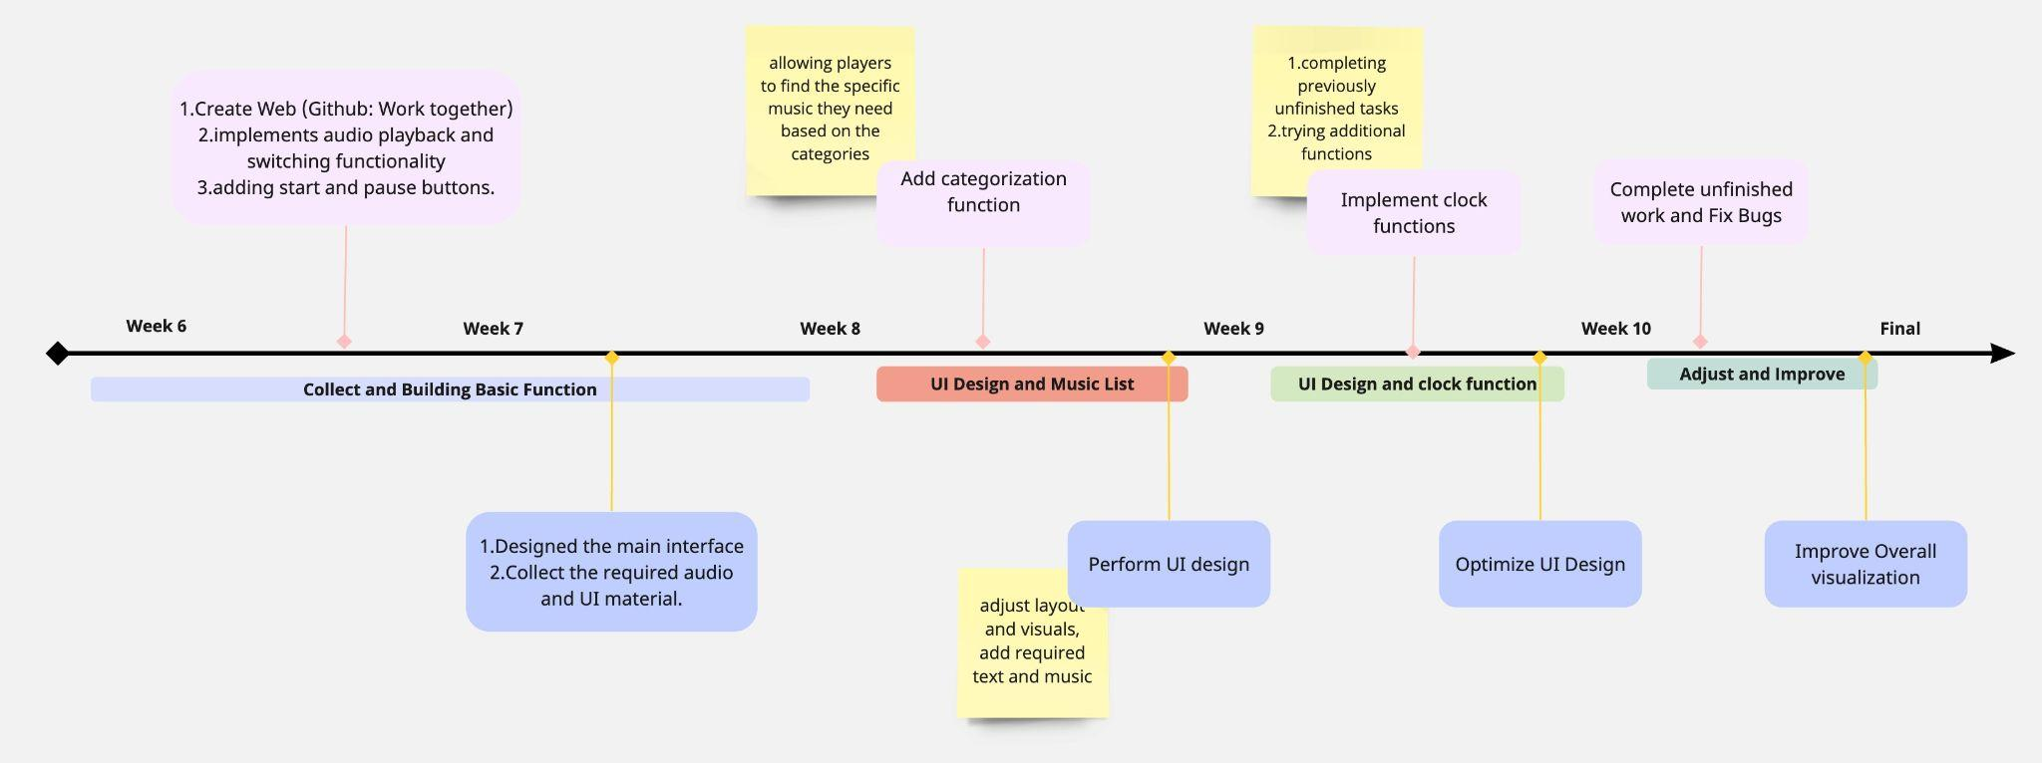

**Essential knowledge you'll need to acquire, sources you will use**

1. **General: JavaScript, HTML, CSS (we both need to learn)**

* We need to familiarize ourselves with the way html and css work to create the UI we want.
* We need to break down our desired outcome into different parts, and work out how the different parts work together.

2. **Resources:**

* We need to search for suitable audio sources, most of them should come from the internet and we need to be aware of copyright issues.

**3. Some current useful links we Found:**

How to make a music player: <https://www.youtube.com/watch?v=JtrFzoL1joI>

How to make a music player: <https://www.bilibili.com/video/BV11f4y1A7nj/?buvid=Y04B4C0FEA5B56194F278D47EFB301D1E414&is_story_h5=false&mid=%2BBp7SquKm1qdpuz5Dz5NQw%3D%3D&p=1&plat_id=122&share_from=ugc&share_medium=iphone&share_plat=ios&share_session_id=13FC7C3F-E168-43F8-9A5D-E073A3B9F122&share_source=COPY&share_tag=s_i&spmid=main.ugc-video-detail.0.0&timestamp=1707814448&unique_k=uFHFHwS&up_id=1468907420&vd_source=1f645d88ea4b4ccbdab581a442b07981>

* I think the video was able to provide us with some of the basics of the program as well as the requirements.

HTML tutorial website：<https://www.w3schools.com/html/>

* This site is very useful, I think I can find most of the things I need about html on it!

Responsive music website:

<https://www.bilibili.com/video/BV1uP41177Lr/?spm_id_from=333.337.search-card.all.click&vd_source=1f645d88ea4b4ccbdab581a442b07981>

* Provides us with ideas on how to build a website as a whole, the video provides the ability to play music as well as certain website features.

Interesting simple animation made in css:

<https://www.bilibili.com/video/BV15b411X7ix/?spm_id_from=333.337.search-card.all.click&vd_source=1f645d88ea4b4ccbdab581a442b07981>

<https://www.bilibili.com/video/BV1pp4y1Y7Ph/?spm_id_from=333.788.recommend_more_video.-1&vd_source=1f645d88ea4b4ccbdab581a442b07981>

<https://www.youtube.com/watch?v=1yAR1eNWbCE>

<https://www.youtube.com/watch?v=1yAR1eNWbCE>

* Interactive animation effects
* Can provide references for UI ideas, very interesting!

HTML + CSS website building ideas:

<https://www.youtube.com/watch?v=-2LtZRi6Q0s&list=PLjwm_8O3suyOwElnplQ3quKEHsOuHyP9R&index=2>

* Provides some references on how to build a website and learn how HTML + CSS works

**Draft - Expected UI design**

